**Salinity-driven changes to emergent food web properties in a salt marsh ecosystem**

Potential journals: Foodwebs, MEPS, Ecosphere, Ecography, Functional Ecology, Ecology

**Abstract**

**Introduction -** Olaf and Jim

Questions:

Q1: Does the marsh fish and invertebrate community differ between high (PS5/7) and low (WPH1) salinity sites?

Q2: Do the diets of key shared taxa differ between the sites?

Q3: Do emergent food web properties differ between sites

Hypothesis: We expect that there are differences between the communities in Q1 and Q2, but what about Q3?

**Methods**

Study Site - Brian, Charlie

This study was conducted in northern Barataria Bay in coastal Louisiana (Figure 1). This estuary is characterized by shallow depths (average 2.3 m), turbid waters, and diurnal tides with a mean daily range of 0.3 m (Conner and Day 1987, Orlando 1993). The estuary is one of the largest in the Gulf of Mexico and is bordered by the Mississippi River to the east, barrier islands such as Grand Isle and Grand Terre to the south, and Bayou Lafourche waterway to the west. Salinity varies seasonally and with freshwater input, typically between 0 and 28 psu. Salt marshes, predominantly *Spartina alterniflora*, dominate the area with lesser contributions from *Juncus roemerianus*, *Distichlis spicata*, and *Spartina patens*, are productive but have been highly susceptible to erosion over the last century (Rakocinski et al. 1992). Specific collection locations included an inshore site near a non-functioning (at the time of this study) water siphon (WPH1), an expansive salt marsh site on a bayou south of Bay Sansbois (PS5), and a higher energy coastline at the northern end of Bay Batiste (PS7).

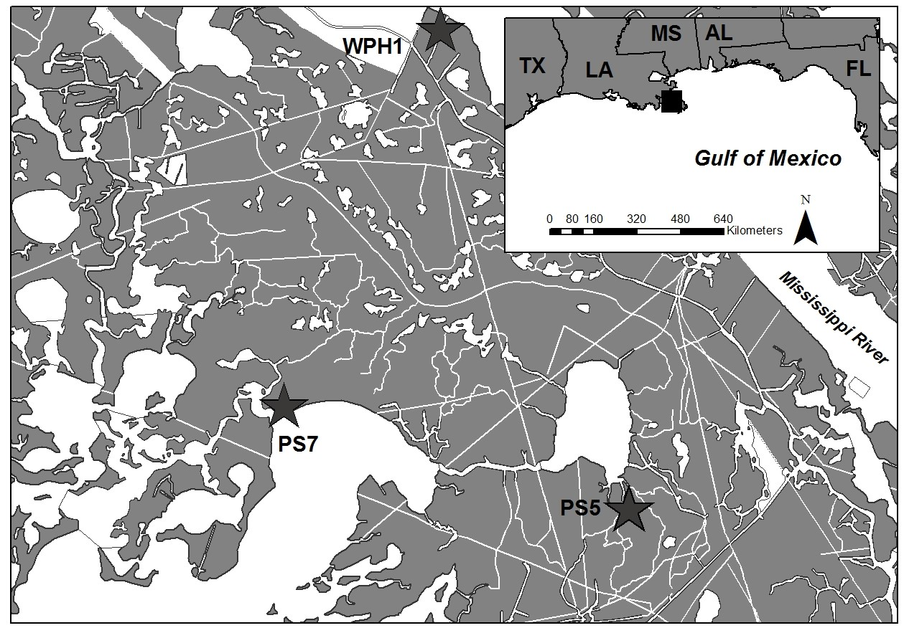

Figure 1: Location of the field sampling sites in northern Barataria Bay, Louisiana, USA. Each site included the salt marsh platform and nearby tidal creeks at the starred locations.

Field Sampling - Charlie, Paola, Brian

Laboratory processing

*Stable Isotopes* - Jill, Paola, Mike

Tissue samples from all individuals were retained for stable isotope analysis of carbon and nitrogen and fatty acid profiles.

Pulled from López-Duarte et al. in prep:

All tissue samples were lyophilized, homogenized, lipid-extracted following standard chloroform-methanol practices (Folch et al. 1957), weighed into tin caps (0.5–1.0 mg) and the relative abundances of carbon (13C/12C) and nitrogen (15N/14N) were determined on a Thermo Finnigan DeltaPlus mass spectrometer (Thermo Finnigan San Jose, California, USA) coupled with an elemental analyzer (Costech, Valencia, California, USA) at the Great Lakes Institute for Environmental Research Stable Isotope Analysis Facility. Precision, assessed by the standard deviation of replicate analyses of four standards [NIST 1577c, internal lab standard (tilapia muscle), USGS 40, Urea (*n* = 64)], measured ≤ 0.15*‰* for δ15N and ≤ 0.14*‰* for δ13C for all the standards. Analytical accuracy, based on the certified values of USGS 40 (*n* = 64) analysed throughout runs showed a difference of -0.03*‰* for δ15N and -0.07*‰* for δ13C from the certified value. Instrumentation accuracy checked throughout the period of time that these samples were analysed was based on NIST standards 8573, 8547 and 8574 for δ15N and 8542, 8573 and 8574 for δ13C (*n* = 20). The mean difference from the certified values were -0.17,-0.10 and -0.14*‰* for δ15N, and -0.10, -0.06 and 0.14*‰* for δ13C, respectively.

*Fatty Acids* - Jill

Fatty acid profiles were quantified using a three-step procedure: (1) triplicate extractions of freeze-dried tissue in a 2:1 chloroform/methanol solution for gravimetric determination of the total lipid (Folch et al. 1957); (2) derivatization of FA methyl esters (FAME) using sulfuric acid in methanol (1:100 mixture; Morrison and Smith 1964, Christie 1989); and (3) identification and quantification of FAME on either a (1) Shimadzu Gas Chromatograph-2010Plus with a flame ionization detector and 100 m × 0.25 mm ID × 0.20 µm film SP-2560 column from Supelco at Ryerson University or (2) Shimadzu Gas Chromatograph 2010 with a flame ionization detector and a 60 m × 0.25 mm ID × 0.25mn film TR-FAME column from Thermo Scientific at Rutgers University. For FAMEs derived from Ryerson University, the FA standards were obtained from Supelco (37 component mix) and Nuchek (54 component mix). A known quantity of an internal standard (a-cholestane; Sigma 170 #C-8003) was added to each sample prior to extraction to provide an estimate of extraction efficiency. Seventy-three FAME were identified using Agilent Technologies ChemStation software via retention time and known standard mixtures and are reported as the percentage of total FA (% TFA). For FAMEs derived at Rutgers University, retention times were standardized to the easily identifiable peak of C16:0 (palmitic acid), and compared with those of FAME standards and FAMEs identified in a subset of samples analyzed on a gas chromatography mass spectrometer (TRACE Ultra/Polar Q by Thermo) at Dalhousie University.

Data Analysis

*Estimating diet proportions from fatty acids and stable isotopes* - Phil

FA profiles were subset to fatty acids that were common (and analysed across laboratories) for all species within each predator-prey combination. The remaining FAs were re-normalised to sum to one, and subsequently analysed using the Bayesian mixing models in the R package fastinR (Neubauer & Jensen 2013).

For each prey species, a library of potential prey items was constructed from sampled species at each site, combining data from PS sites. We assumed that all species were available to predators at each site. To give effect to this assumption, we preferentially used samples from the site of collection for predators at each site (e.g., prey items sampled at PS sites for predators sampled from PS sites), but augmented the potential prey library with samples from other sites if they did not occur in sampling at the same site that predators were sampled from - a lack of a potential prey species was therefore assumed to be due to sampling rather than actual absence of the species at the site.

Prey fatty acid profiles in the model were adjusted using conversion coefficients taken from controlled diet studies for each of the predator species (McCann et al. in prep, Mohan et al. 2016). Fatty acids were jointly analysed with stable isotope signatures to increase the resolution of the biomarker set for determining diets. Stable isotope fractionation was taken from controlled experiments in McCann et al. (in prep), but as fractionation is usually prey specific (i.e., depending on prey protein content and predator requirements relative to availability of amino acids in prey; Hussey et al 2014), we used relatively wide standard deviations (SD=1) for the prior distribution of fractionation coefficients. Code for the analysis can be found at <https://github.com/dragonfly-science/Tracer-models-GoM>.

*Trophic Position and Basal Carbon Sources from Stable Isotope Analysis*

We used a Bayesian approach to estimate the trophic position (TP) and the relative importance of aquatic vs. terrestrial carbon sources (α) to consumers collected between sites and seasons using package ‘tRophicposition’ (Version 0.7.5; Quezada-Romegialli et al. 2018) implemented in R. Using this Bayesian formulation of the TP equations outlined in Post et al. (2002) we assumed two dominant food web baselines: terrestrial C4 marsh vegetation and aquatic algae sources. We used site-specific stable isotope values of two herbivorous terrestrial insects (primary consumers; assumed TP = 2) in the Order Hemiptera: *Prokelisia spp.* and *Ischnodemus spp.* as proxies for the terrestrial baseline. We used site-specific stable isotope values of suspension feeding bivalves (primary consumers; assumed TP = 2) ribbed mussels (*Geukensia granossissima*) and eastern oyster (*Crassostrea virginica*) supplemented with site-specific suspended particulate organic matter samples (SPOM; assumed TP = 1) stable isotope values to represent the aquatic baseline. SPOM stable isotope values were normalized to primary consumer baslines (i.e. TP = 2) by adding the assumed mean trophic discrimination factors from Post (2002; Δ13C = 0.39; Δ15N = 3.4). Bayesian estimations of TP and α were obtained from 100,000 iterations trimmed by the first 10,000 using the ‘Two Baselines Full’ model (Quezada-Romegialli et al. 2018). We incorporated an assumed mean trophic discrimination (Δ13C = 0.39 ± 1.30‰; Δ15N = 3.4 ± 0.98‰) per trophic transfer (Post 2002) and the resulting TP and α metrics are reported as modal values. TP and α was calculated for brackish conditions (PS5 and PS7 combined) and fresh conditions (WPH1) separately for consumer groups that were found in both conditions (Supplementary Tables SX, SX, SX). Credibility Interval (95%) were calculated when at least three samples per group were available. Bayesian posterior probabilities (PP > 0.95) resulting from pairwise comparisons of posterior distributions of group TP and α values between brackish (PS5 and PS7) and fresh (WPH1) were used to identify significant differences.

*Trophic ecosystem models* - Jim

To determine if emergent foodweb properties differed between the high and low salinity sites we utilized Ecopath (v6.6) to develop trophic models for each site. Ecopath creates a mass-balanced model of the components and interactions within an ecosystem at a single point in time by trophically linking biomass pools (Christensen and Walters, 2004). For our models the biomass pools represented particular ontogenetic stages of an individual species (*i.e.*juvenile *Sciaenops ocellatus*), all life stages of a particular species (*i.e. Lagodon rhomboides*), or a group of species representing a particular guild (*i.e.* killifishes). Input parameters required for each biomass pool include diet composition, biomass accumulation, net migration, catch, and three of the following four parameters: biomass (B), production/biomass (P/B), consumption/biomass (Q/B), and Ecotrophic Efficiency (EE) which is the fraction of the production consumed or harvested within the system. These parameters are then utilized in two master equations. The first equation describes the production term for each group:

*Production = catch + predation + net migration + biomass accumulation + other mortality*

The second equation balances the energy flows of a biomass pool:

*Consumption = production + respiration + unassimilated food*

The Ecopath models utilized in this study contain 34 distinct biomass groups including 14 fish species, 8 benthic invertebrate groups, 2 insect groups, 2 planktonic groups, 2 benthic vegetation groups, 2 marsh vegetation groups, 3 bird groups, and a detrital pool (Figures X and X). They were based on the Barataria Bay model of Oken *et al*. (in prep) modified to be consistent with the salt marsh platform and marsh channel communities modeled here compared to the open-bay representation of the original model. Large-bodied predator groups (adult sharks and dolphins) not typically found in marsh channels were not included in our models. The Oken *et al.* Barataria Bay model also included separate adult and juvenile groups for several species; the adult stages of several fish species were not commonly found within the study area and were therefore not included in these models.

The vital rates for each group (P/B, Q/B) used to parameterize our models were taken from the balanced Oken *et al.* model (see Appendix Xa for source descriptions). For the high salinity model, initial biomasses were taken from the Oken *et al.* balanced open bay model. Initial biomasses for each group in the low-salinity model were determined by multiplying the balanced biomass of the high salinity model by the ratio of field determined CPUEs between the sites for the gear in which the group was most prevalent, if available (Appendix Xb). For both models EE values were derived from solving the mass balance equations except for the two insect groups, which were taken from the literature.

The diet matrices (Appendix Xc) were modified from Oaken *et al.* to account for the differences in model construction; adult sharks and dolphins were removed as predator and prey items, and for groups within our model that were multi-stanza in Oken *et al*. the prey item proportions were averaged across the stanzas. Additionally, the diets of the three groups determined through site specific biomarker analysis (blue crabs, croaker/spot/perch, killifishes) were utilized.

Model balancing was conducted in an iterative process, and generally followed the best practices identified by (Heymans et al ?), including the use of the PREBAL routine (Link, 2010) to identify issues in model structure and data quality associated with the initial input parameter values before balancing the model.

A number of different ecosystem metrics were calculated and analyzed for each of the models developed. From an energy flow perspective, we looked at total system biomass, total system throughput, and Finn’s cycling index. As its name suggests, total system biomass is the sum of all of the component biomasses within the model. Total system throughput is the sum of all flows in the system [*i.e.*  the sum of the throughputs (respiration + flow to detritus+ export +consumption by predators) at each trophic level] and reflects the ecological size of the system (Christensen et al. 2008).Finn’s ‘cycling index’ (Finn 1976) is the fraction of an ecosystem's throughput that is recycled. This index strongly correlates with system maturity, resilience, and stability (Christensen 1995). We also calculated several metrics of ecosystem structure, including mean path length, system omnivory index, and system resiliency. Mean path length is the average number of groups a flow passes through, and is a measure of the retention time of material within the system. The system omnivory index describes how feeding interactions are distributed among the trophic levels in each model. A value close to zero suggests XXXXXX, while a large value suggests…...Lastly, we calculated three related measures of system resilience; ascendency, capacity, and system overhead (Ulanowicz 1986). The difference between capacity and ascendency is the system overhead, and is thought to reflect how much capability the system has to respond to perturbations.

**Results**

*Marsh fish and invertebrate communities*

Marsh fish and invertebrate communities were broadly similar across both salinity regimes, though species richness was higher at the brackish sites (PS5/7) compared to the freshwater site (WPH). Of the 51 species or genera captured during field sampling, 18 were found at both salinities, 12 only at the freshwater site, and 21 only at the brackish sites (Fig. X). The species occurring at both high and low salinities tended to be found in similar abundances across the sites with the exception of *Cynoscion arenarius*, which had significantly higher abundances at the freshwater site. Of the species captured only at the freshwater site, Ictalurid catfish (*Ictalurus punctatus* and *I. furcatus*), *Morone chrysops*, and *Eleotris pisonis* were the only ones found in significant abundances. For the species captured only at the brackish sites those with significant abundances were limited to the marsh snails (*Melampus bidentatus* and *Littoraria irrorata*).

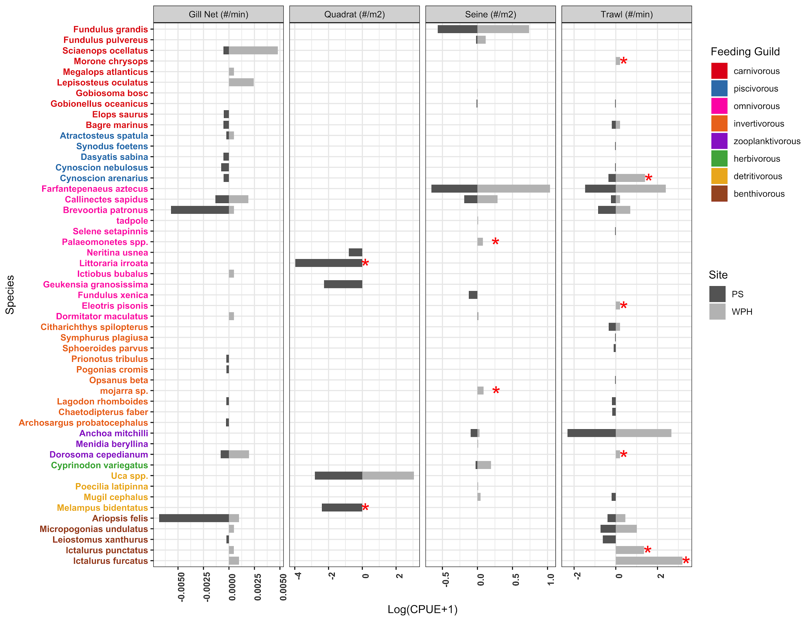

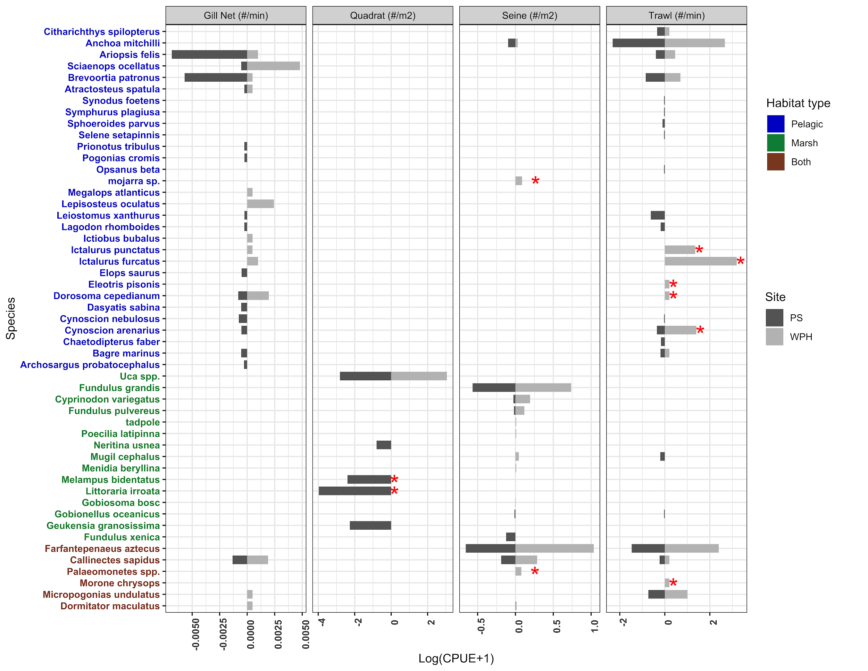

Fig X. Differences in CPUE between freshwater (WPH) and brackish (PS5/7) sites for the four field sampling gears. An * denotes a statistically significant difference (*p* < 0.05) between the sites for that particular species/gear combination based on a Wilcoxon ranked sum test.

*Diets of key shared taxa*

Diet proportions from fatty acids and stable isotopes

Diets for fish predators appeared similar between brackish (PS5/7) and the freshwater marsh site (WPH1; Fig. X). Atlantic Croaker showed slightly higher consumption of blue crab, but lower consumption of herbivorous infauna at brackish sites relative to the freshwater site. Killifish diet tracers suggested somewhat larger amounts of carnivorous infauna consumption at brackish sites. However, taking into account uncertainty about diets inferred from tracers, the differences in fish diets were minor compared with inferred diet differences for blue crab. Some diet items, like Killifishes and carnivorous infauna, appeared in Blue crab diets at both brackish and freshwater sites. However, other diet items, like *Geukensia demissa* only appeared in diets at brackish sites, whereas *Crassostrea veronica*, *Melampus coffeus* and *Littoraria irrorata* were contributing to Bluecrab diets only at the freshwater site (Fig X).

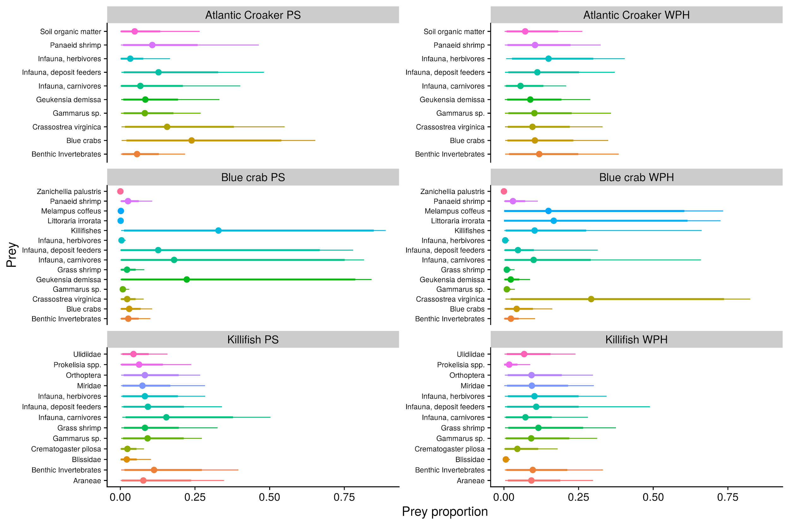

Fig X. Posterior distributions for diets of Atlantic Croaker, Blue Crabs, and Killifish at brackish (PS5/7) and freshwater (WPH) sites. Points indicate posterior means used to calibrate the EwE model; thick lines are the 80% posterior quantiles, and thin lines show 95% posterior quantiles.

*Emergent food web properties*

Trophic position and basal carbon sources

Stable isotope-based calculated trophic positions of consumer groups at brackish (PS5/7) marsh sites ranged from a low of 2.23 (95%CI: 2.04-2.39) in herbivorous insects to a high of 3.60 (95%CI: 3.20-4.01) in gar (Fig. X). At the freshwater marsh site adjacent to the West Pointe à la Hache Siphon (WPH1) calculated trophic positions of consumer groups ranged from a low of 2.23 (95%CI: 2.00-2.54) in herbivorous insects to a high of 3.12 (95%CI: 2.32-3.81) in the croaker-spot-perch group (Fig. X). We found no differences (all PP < 0.95) in the pairwise comparisons of posterior distributions of any individual consumer group TP values between brackish (PS5/7) and fresh (WPH1) marsh sites (Table X).

Stable isotope-based calculated basal carbon source use (α) of consumer groups at brackish (PS5/7) marsh sites ranged from taxa such as herbivorous insects with the highest use of terrestrial basal carbon sources (α: 0.11; 95%CI: 0.05-0.16) to the croaker-spot-perch group with the highest use of aquatic basal carbon source (α: 0.69; 95%CI: 0.64-0.74; Fig. X). At the freshwater marsh site adjacent to the West Pointe à la Hache Siphon (WPH1) calculated trophic positions of consumer groups ranged from taxa such as herbivorous insects with the highest use of terrestrial carbon sources (α: 0.06; 95%CI: 0.00-0.23) to the croaker-spot-perch group with the highest use of aquatic carbon source (α: 0.98; 95%CI: 0.75-0.10; Fig. X). Four consumer groups differed in pairwise comparisons of posterior distributions of α values between brackish (PS5/7) and fresh (WPH1) marsh sites (Table X). Grass shrimp, killifishes, croaker-spot-perch, and catfish groups all had relatively significantly higher use of aquatic basal carbon source at fresh (WPH1), relative to brackish (PS5/7) marsh sites (PP > 0.95; Table X).

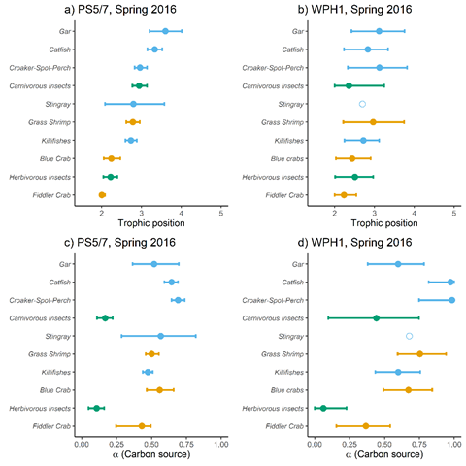

**Figure X.** Trophic position (a,b) and basal carbon source use (α; c,d) of consumer groups at brackish (PS5 and PS7 combined) and freshwater (WPH1; i.e. adjacent to the West Pointe à la Hache Siphon) marsh sites in Barataria Bay, LA in May 2016 derived from carbon and nitrogen stable isotope values. Filled circles are predicted mode ± 95% CI of organisms where n > 3 and open circles are predicted mode of organisms where n ≤ 3, Estimates are color coded by functional group. Terrestrial carbon sources reflect ⍺ = 0.0 and aquatic carbon sources reflect ⍺ = 1.0.

**Table X.** Trophic position and basal carbon sources of consumer groups at brackish (PS5 and PS7 combined) and freshwater (WPH1; i.e. adjacent to the West Pointe à la Hache Siphon) marsh sites in Barataria Bay, LA in May 2016 derived from carbon and nitrogen stable isotope values. Value are presented mode (± 95% CI). Terrestrial carbon sources reflect ⍺ = 0.0 and aquatic carbon sources reflect ⍺ = 1.0. Groups with significant differences (PP > 0.95) between pairwise comparisons of posterior distributions of group TP and α values between brackish (PS5 and PS7) and fresh (WPH1) are identified using bold type.

|  |  |  |  |  |  |
| --- | --- | --- | --- | --- | --- |
| Group | Trophic position | |  | α | |
| PS | WPH |  | PS | WPH |
| Herbivorous insects | 2.23 (2.04-2.39) | 2.51 (2.01-2.97) |  | 0.11 (0.05-0.16) | 0.06 (0.00-0.23) |
| Carnivorous insects | 2.94 (2.77-3.14) | 2.36 (2.00-3.24) |  | 0.17 (0.11-0.22) | 0.44 (0.10-0.75) |
| Blue crabs | 2.24 (2.06-2.46) | 2.44 (2.03-2.9) |  | 0.56 (0.47-0.66) | 0.67 (0.49-0.84) |
| Fiddler crab | 2.00 (2.00-2.08) | 2.23 (2.00-2.54) |  | 0.43 (0.25-0.50) | 0.37 (0.16-0.54) |
| Grass shrimp | 2.78 (2.62-2.95) | 2.97 (2.22-3.74) |  | **0.50 (0.46-0.55)** | **0.75 (0.59-0.94)** |
| Killifishes | 2.73 (2.59-2.88) | 2.72 (2.25-3.11) |  | **0.47 (0.44-0.51)** | **0.60 (0.43-0.76)** |
| Croaker-Spot-Perch | 2.96 (2.82-3.14) | 3.12 (2.32-3.81) |  | **0.69 (0.64-0.74)** | **0.98 (0.75-1.0)** |
| Catfish | 3.33 (3.15-3.51) | 2.83 (2.23-3.34) |  | **0.64 (0.59-0.69)** | **0.97 (0.82-1.0)** |
| Stingray | 2.79 (2.08-3.57) | 2.70 |  | 0.57 (0.29-0.82) | 0.68 |
| Gar | 3.60 (3.20-4.01) | 3.12 (2.42-3.75) |  | 0.52 (0.36-0.7) | 0.6 (0.38-0.78) |

*Food web models*

The static models shown in Fig. X represent balanced models of the trophic connections within the brackish (PS5/7) and freshwater (WPH) sites in 2016 with the groups arranged by trophic level. For the brackish sites after the initial model run the biomasses for several groups were adjusted down to better reflect their abundances in the study area compared to Oaken *et al.* (pelicans, diving birds, penaeid shrimp, croaker/spot/perch). For both models the diets of the three groups determined through the site-specific biomarker analysis were further modified to include a detrital pool and other known prey items that were not part of the biomarker analysis. This was necessary due to over-reliance on a limited number of prey items that led to excessive predation mortalities. The initial EE values for the two insect groups were also modified as part of the model balancing procedure. The final parameters for each model are given in Table Xa and Xb.

The freshwater model (WPH) had a slightly larger total system biomass than the brackish model (PS5/7) (~2%), with all other key food web metrics generally similar (Table X). The mean path length for trophic flows were identical between models and indicates that a flow passes through slightly more than two groups, on average. For both models the system overhead values were twice that of the ascendancy values, suggesting substantial capacity for response to perturbations.

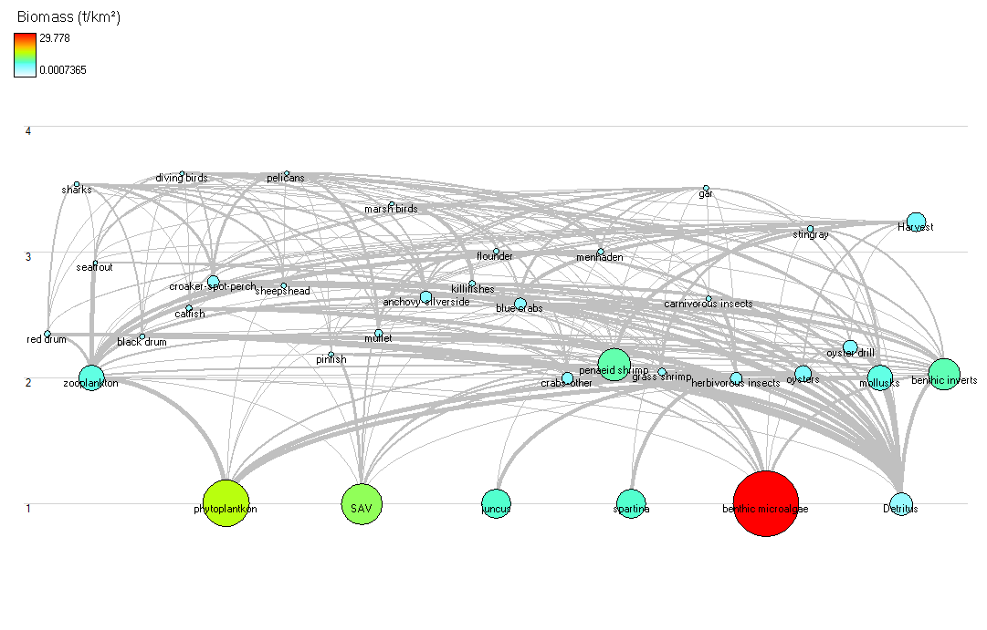

Fig X. The foodweb flow diagram for brackish (PS5/7) sites in 2016. The size of the circle is scaled to the biomass of the group, and it’s vertical position in the diagram represents its model calculated trophic level.

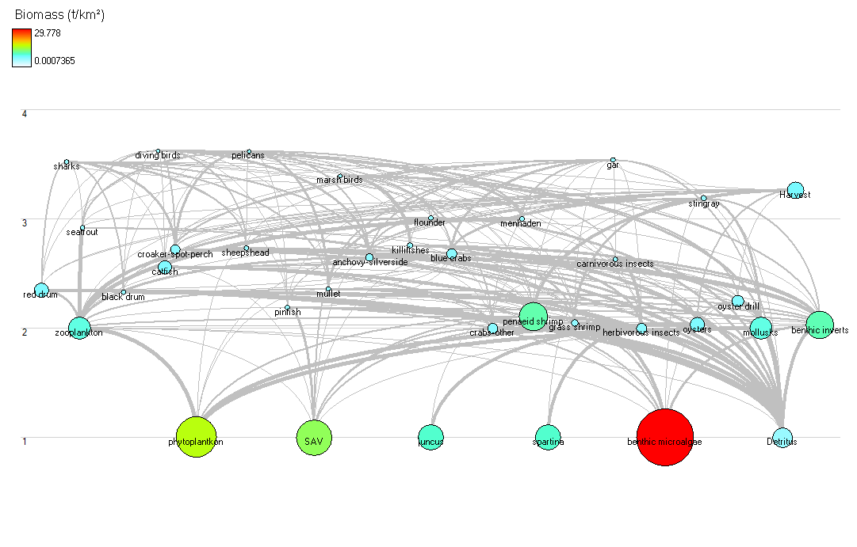

Fig X. The foodweb flow diagram for the freshwater (WPH) site in 2016. The size of the circle is scaled to the biomass of the group, and it’s vertical position in the diagram represents its model calculated trophic level.

|  |  |  |  |  |  |  |
| --- | --- | --- | --- | --- | --- | --- |
| Table X: Basic input parameters for the Barataria Bay brackish (PS5/7) ecosystem model. Catch includes fishery landings. Biomass, P/B, Q/B, and catch estimates are from a variety of sources as described in Supplemental X. Trophic level and Ecotrophic Efficiency were estimated by Ecopath (except where noted with *). | | | | | | |
| Group name | Trophic level | Biomass (t/km2) | P/B (year-1) | Q/B (year-1) | Ecotrophic Efficiency | Catch (t/km2) |
| Sharks | 3.54056 | 0.08443068 | 2 | 17.96 | 0.023688 |  |
| Diving birds | 3.628351 | 0.0007365 | 0.1 | 50 | 0 |  |
| Pelicans | 3.630806 | 0.0014936 | 0.1 | 17.7 | 0 |  |
| Marsh birds | 3.38701 | 0.0013 | 5.475 | 87.6 | 0 |  |
| Red drum | 2.347111 | 0.2 | 2.2 | 4.5 | 0.468282 |  |
| Seatrout | 2.9189 | 0.00275 | 3.7 | 29.1 | 0.810303 |  |
| Black drum | 2.328047 | 0.1087879 | 2 | 22.64 | 0.783603 |  |
| Catfish | 2.550251 | 0.1733824 | 0.8 | 3.3 | 0.41792 |  |
| Croaker-spot-perch | 2.768111 | 0.9450404 | 1.5 | 8.84 | 0.409848 |  |
| Sheepshead | 2.7332 | 0.0975 | 2 | 14.6 | 0.748252 |  |
| Flounder | 3.007921 | 0.01228 | 2 | 13.31 | 0.537977 |  |
| Pinfish | 2.187215 | 0.09 | 0.7 | 8 | 0.135157 |  |
| Menhaden | 3 | 0.17 | 2.3 | 19.38 | 0.24512 |  |
| Mullet | 2.358341 | 0.38 | 2.4 | 33 | 0.488903 |  |
| Anchovy-silverside | 2.64717 | 0.9519196 | 2.3 | 19.4 | 0.358933 |  |
| Gar | 3.509939 | 0.04 | 0.48 | 2.25 | 0.104167 |  |
| Stingray | 3.181282 | 0.16 | 0.48 | 1 | 0.219638 |  |
| Killifishes | 2.746527 | 0.215 | 2.53 | 19.4 | 0.996903 |  |
| Blue crabs | 2.592322 | 1.006483 | 2.4 | 8.5 | 0.762874 |  |
| Crabs-other | 2.000051 | 1 | 4.5 | 18 | 0.264338 |  |
| Penaeid shrimp | 2.105513 | 6.282031 | 2.4 | 19.2 | 0.142985 |  |
| Grass shrimp | 2.051282 | 0.446431 | 4.5 | 18 | 0.490049 |  |
| Carnivorous insects | 2.63 | 0.0899579 | 6 | 30 | 0.42* |  |
| Herbivorous insects | 2 | 0.9816964 | 6 | 30 | 0.42* |  |
| Oysters | 2.033333 | 1.9206 | 2.4 | 10 | 0.812682 |  |
| Oyster drill | 2.24304 | 1.5 | 4.5 | 18 | 0.012729 |  |
| Mollusks | 2 | 4.033359 | 3 | 15 | 0.51906 |  |
| Benthic invertebrates | 2.025641 | 6 | 4.5 | 22 | 0.679627 |  |
| Zooplankton | 2 | 4.124 | 28.77 | 84.87 | 0.201873 |  |
| Phytoplankton | 1 | 12.8381 | 101.7 |  | 0.290431 |  |
| SAV | 1 | 9.778 | 9.01 |  | 0.49569 |  |
| Juncus | 1 | 5 | 3 |  | 0.990692 |  |
| Spartina | 1 | 5 | 2.99 |  | 0.994006 |  |
| Benthic microalgae | 1 | 29.778 | 3.91 |  | 0.568145 |  |
| Detritus | 1 |  |  |  | 0.19877 |  |

|  |  |  |  |  |  |  |
| --- | --- | --- | --- | --- | --- | --- |
| Table X: Basic input parameters for the Barataria Bay freshwater (WPH) ecosystem model. Catch includes fishery landings. Biomass, P/B, Q/B, and catch estimates are from a variety of sources as described in Supplemental X. Trophic level and Ecotrophic Efficiency were estimated by Ecopath (except where noted with *). | | | | | | |
| Group name | Trophic level | Biomass (t/km2) | P/B (year-1) | Q/B (year-1) | Ecotrophic Efficiency | Catch (t/km2) |
| Sharks | 3.522243 | 0.0211 | 2 | 17.96 | 0.094787 |  |
| Diving birds | 3.625674 | 0.000737 | 0.1 | 50 | 0 |  |
| Pelicans | 3.621706 | 0.001494 | 0.1 | 17.7 | 0 |  |
| Marsh birds | 3.397006 | 0.0013 | 5.475 | 87.6 | 0 |  |
| Red drum | 2.347295 | 1.78 | 2.2 | 4.5 | 0.01357 |  |
| Seatrout | 2.919106 | 0.017875 | 3.7 | 29.1 | 0.148526 |  |
| Black drum | 2.328139 | 0.108788 | 2 | 22.64 | 0.315092 |  |
| Catfish | 2.560032 | 1.73 | 0.8 | 3.3 | 0.036389 |  |
| Croaker-spot-perch | 2.71923 | 0.846269 | 1.5 | 8.84 | 0.181929 |  |
| Sheepshead | 2.7332 | 0.0975 | 2 | 14.6 | 0.229662 |  |
| Flounder | 3.008339 | 0.0053 | 2 | 13.31 | 0.74554 |  |
| Pinfish | 2.188142 | 0.043 | 0.7 | 8 | 0.352941 |  |
| Menhaden | 3 | 0.0868 | 2.3 | 19.38 | 0.282968 |  |
| Mullet | 2.3588 | 0.043 | 2.4 | 33 | 0.845852 |  |
| Anchovy-silverside | 2.647183 | 0.543 | 2.3 | 19.4 | 0.319468 |  |
| Gar | 3.540582 | 0.08 | 0.48 | 2.25 | 0.052083 |  |
| Stingray | 3.185762 | 0.16 | 0.48 | 1 | 0.054889 |  |
| Killifishes | 2.753165 | 0.2451 | 2.53 | 19.4 | 0.954052 |  |
| Blue crabs | 2.684086 | 1.028132 | 2.4 | 8.5 | 0.859246 |  |
| Crabs-other | 2.000051 | 1 | 4.5 | 18 | 0.316925 |  |
| Penaeid shrimp | 2.105513 | 6.282031 | 2.4 | 19.2 | 0.145344 |  |
| Grass shrimp | 2.051282 | 0.446431 | 4.5 | 18 | 0.311775 |  |
| Carnivorous insects | 2.63 | 0.102802 | 6 | 30 | 0.5 |  |
| Herbivorous insects | 2 | 0.957581 | 6 | 30 | 0.5 |  |
| Oysters | 2.033333 | 1.9206 | 2.4 | 10 | 0.912691 |  |
| Oyster drill | 2.24304 | 1.4 | 4.5 | 18 | 0.071986 |  |
| Mollusks | 2 | 4.033359 | 3 | 15 | 0.552053 |  |
| Benthic invertebrates | 2.025641 | 6 | 4.5 | 22 | 0.578686 |  |
| Zooplankton | 2 | 4.124 | 28.77 | 84.87 | 0.169378 |  |
| Phytoplankton | 1 | 12.8381 | 101.7 |  | 0.289943 |  |
| SAV | 1 | 9.778 | 9.01 |  | 0.481925 |  |
| Juncus | 1 | 5 | 3 |  | 0.967861 |  |
| Spartina | 1 | 5 | 2.99 |  | 0.971098 |  |
| Benthic microalgae | 1 | 29.778 | 3.91 |  | 0.550622 |  |
| Detritus | 1 |  |  |  | 0.196319 |  |

|  |  |  |
| --- | --- | --- |
| Table X: Key emergent food web metrics for each site as calculated in the Ecopath modeling software. | | |
| **Ecosystem Metric** | **PS** | **WPH** |
| Total biomass (t/km2) *excludes detritus | 93.413 | 95.5 |
| Total system throughput (t/km2/yr) | 3630.994 | 3629.776 |
| System Omnivory Index | 0.139 | 0.140 |
| Finn’s cycling index (% of total throughput) | 2.531 | 2.643 |
| Finn’s mean path length | 2.357 | 2.357 |
| Ascendency (%) | 33.29 | 33.41 |
| Overhead (%) | 66.71 | 66.59 |

**Discussion**

*Are the marsh fish and invertebrate communities similar*

*Do the diets of key shared taxa differ between the sites*

The results of the biomarker analysis of the diets of killifishes and Atlantic croaker suggest that the diet of each taxa are similar under both salinity regimes, with minor differences likely associated with prey availability. How does this match up with literature?

This contrasts with blue crab, where Melampus and Littoraria were a substantial component of the diet at the freshwater site but not at the brackish site. However, field sampling conducted at the same time as the collection for biomarker samples suggests that these snails are not present at the freshwater site in appreciable abundance. This suggests that 1) the crabs may have been feeding on these snails at another location prior to their capture, 2) the field methodology did not adequately sample for snails, or 3) the crabs may have eaten a prey item with a similar biomarker signature to the snails, and that prey item wasn't sampled for biomarker analysis. Regardless of the actual process and pathway, the results indicate that blue crabs feed differently between the freshwater and brackish sites.

*Do emergent food web properties differ between sites*

The trophic position of select species did not vary significantly between brackish and freshwater sites based on the stable isotope analysis and Ecopath models, but there were small discrepancies between the values derived by each method. The Ecopath values generally fell within the confidence intervals established for the stable isotope analysis (12 out of 20 species/sites combinations) with the exception of grass shrimp (both sites lower), catfish, croaker, and insects (all lower at the brackish site), and blue crabs (higher at the brackish site). Is this novel or inline with other studies?

The food web properties of interest to us were generally fixed through the static model connections - unless there was a dramatic change in diets the networks should be stable between sites. While blue crabs showed a difference in diet composition between sites based on the biomarker analysis, the individual changes were within a single Ecopath group (mollusks), and thus did not strongly affect the model balancing and results. Compare to other systems - maturity/stability/resiliency. Lots of overhead suggests ability to bounce back from perturbations.

While most of the Ecotrophic Efficiency values as calculated by the model suggested that there was excess production in the system compared to what we would have expected, this can likely be explained through “emmigration”, which we did not account for in the model parameterization. Our fish components were primarily focused at the juvenile level, and many of the species included in the model spend their early life history in the relatively protected marsh habitats before leaving for the open bay, where they would be more vulnerable to predation.

The exception to this phenomenon are the two groups making up the marsh grasses (Juncus and Spartina). Their EEs are close to 1, suggesting that nearly all of their production is utilized within the system, which we know is not likely to be the case (citation for marsh production export/detrital pool?). The high proportion of use in the system appears to be driven primarily by predation from herbivorous insects, whose biomass in the model is dictated by their availability as a prey item, primarily for killifish. The biomarker data indicated that herbivorous insects made up over 30% of the killifish diet. While this percentage was reduced during model balancing, it does suggest that there may have been other important prey items missing from the killifish diet that were not included in the analysis.

**Acknowledgements**

GIIDC DOIs

**References**

Christensen, V. 1995. Ecosystem maturity - towards quantification. Ecological Modelling, 77(1):3-32.

Christensen, V. and Walters, C.J., 2004. Ecopath with Ecosim: methods, capabilities and limitations. *Ecological Modelling,* 172,109-139.

Christensesn, V., Walters, C.J., Pauly, D., and Forrest, R. 2008. Ecopath with Ecosim Version 6 User Guide.

Christie, W. W. 1989. Gas chromatography and lipids. P.J. Barnes and Associates (The Oily Press), Bridgewater, UK.

Conner, W. H., & Day, J. W. (Eds.). (1987). The ecology of Barataria Basin, Louisiana: an estuarine profile (Vol. 85). National Wetlands Research Center, US Fish and Wildlife Service, US Department of the Interior.

Folch, J., M. Lees, and G. H. Sloane-Stanley. 1957. A simple method for the isolation and purification of total lipids from animal tissues. Journal of Biological Chemistry 226:497–509.

Link, J.S., 2010. Adding rigor to ecological network models by evaluating a set of pre-balance diagnostics: A plea for PREBAL. Ecological Modelling, 221, 1580–1591.

Mohan, S. D., Mohan, J. A., Connelly, T. L., Walther, B. D., & McClelland, J. W. (2016). Fatty‐acid biomarkers and tissue‐specific turnover: validation from a controlled feeding study in juvenile Atlantic croaker Micropogonias undulatus. Journal of fish biology, 89(4), 2004-2023.

Morrison, W. R., and L. M. Smith. 1964. Preparation of fatty acid methyl esters and dimethylacetals from lipids with boron fluoride-methanol. Journal of Lipid Research 5:600–608.

Neubauer and Jensen 2013

Orlando, S. P. (1993). Salinity characteristics of Gulf of Mexico estuaries. Strategic Environmental Assessments Division, Office of Ocean Resources Conservation and Assessment, National Ocean Service, National Oceanic and Atmospheric Administration.

Rakocinski, C. F., Baltz, D. M., & Fleeger, J. W. (1992). Correspondence between environmental gradients and the community structure in Mississippi Sound as revealed by canonical correspondence analysis. Marine Ecology Progress Series, 80, 135-257.

**Appendices/Supplementary Tables**

CPUE comparisons between PS5 and PS7

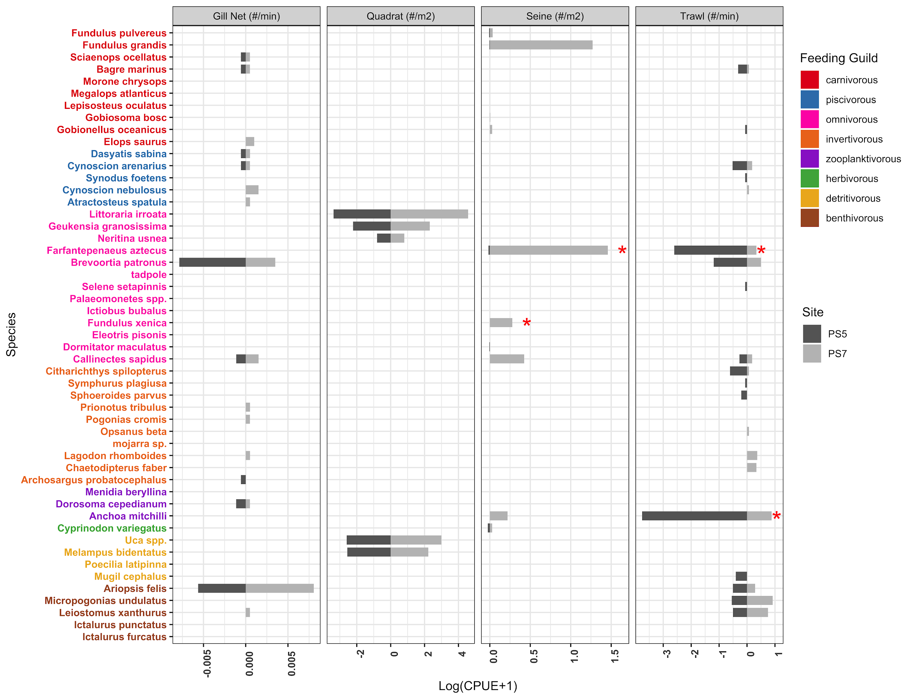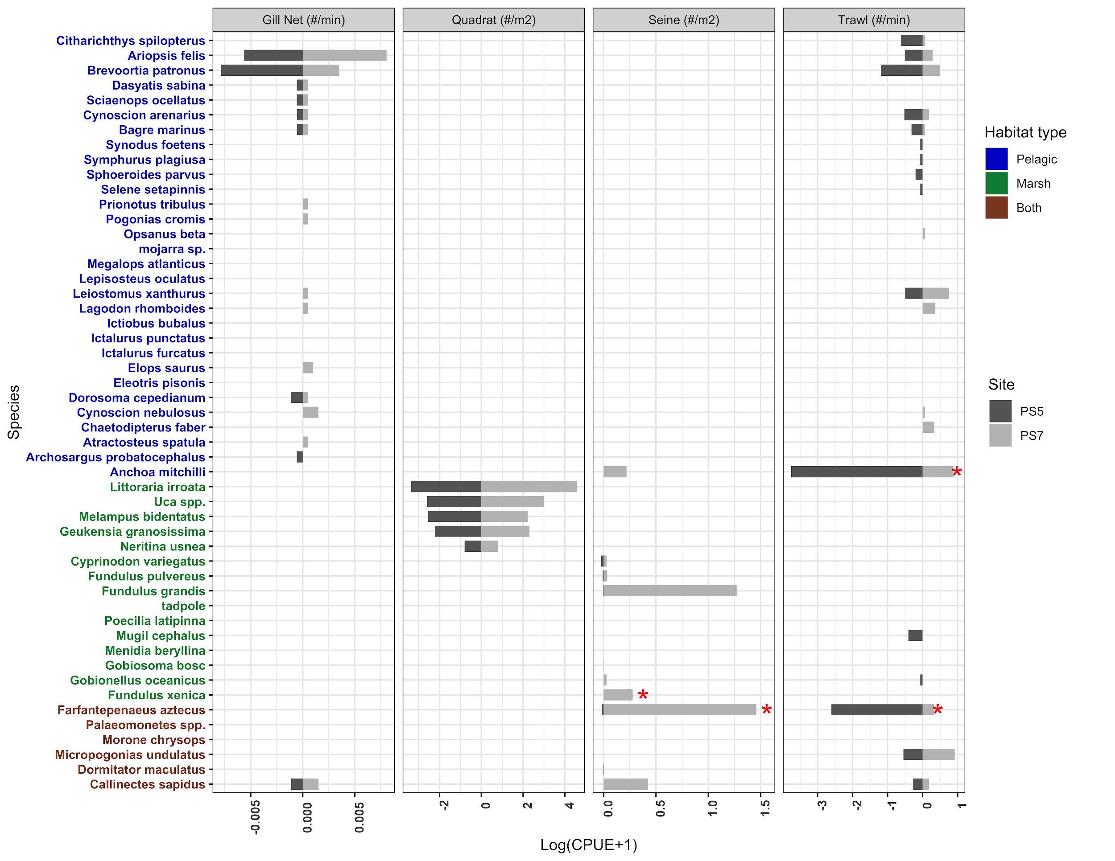

SI/FA details

Number of individuals (n) and stable carbon (δ13C) and nitrogen (δ15N) isotope values (mean ± SD) for the taxa collected from PS5, PS7, and WPH - 3 tables

Multiple EwE tables